Central University of Haryana
Matrix I/O
Write a program to read a matrix of size m*n from the keyboard and display the same using function.
Rudra Chinhara
2-21-2022

Github Link

CODE
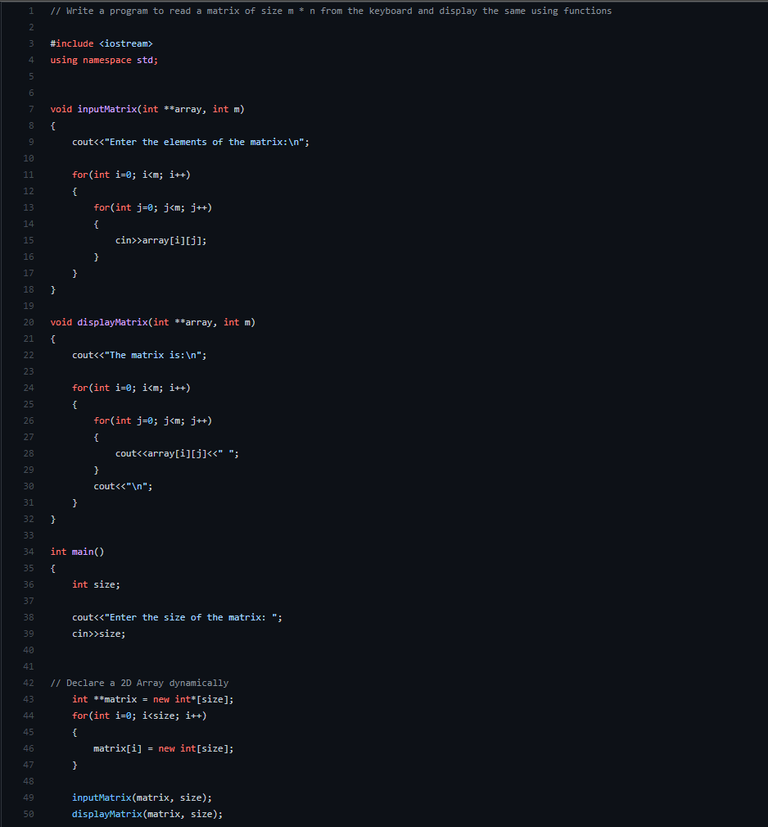

OUTPUT
